Garrett Badalich
Application Paper
Memes. They aren’t usually talked about in an academic context, but they do provide some merit and insight into how people behave, and they are worth studying. According to Hall and Sinclair, “a meme is a humorous image that is copied, often with slight variations, and spread by internet users. Memes provide one way that political information can be shared”. This is important because in the age of new media, information is not spread the same way that it was 40 years ago. Back then, ideas were spread through television, the nightly news, or reading about something in the newspaper. The internet allows people to post their daily thoughts to social media, whether or not they have merit, or they supply anything constructive to the marketplace of ideas. This can be a good thing because it takes the power away from gatekeepers in media that try to regulate what messages are distributed and which are filtered out. With the internet, there isn’t any sort of checking over or restriction of what can or cannot be said. Memes are the spreading of ideas, jokes, or references that sometimes can just be dumb jokes that don’t mean anything (“Peach Time”) or other times can help influence elections (“binders full of women”).
Academically, memes examine three concepts: humor, intertextual reference, and anomalous juxtaposition. Humor is subjective, because there are a lot of things that one person can think is funny, but someone else may disagree. Replication, in most cases, has a negative effect on comedy. The more and more that the same joke is told, the more “stale” it becomes, and then usually the joke becomes less funny. In the 2008 comedy Step Brothers, Will Ferrell says something to John C. Reilly, and he responds with “That’s so funny. The last time I heard that one I laughed so hard I fell off my dinosaur”. Maybe, when this movie first came out, that might have been a completely zany, witty comeback, but some parts of Step Brothers (including this joke), have been quoted so often and retold so many times that the quote loses its charm. It’s not as funny anymore, and it’s not the fault of the writers of the script, it is what internet connoisseurs would refer to as a “dead meme”.
Memes have intertextual reference, meaning that it is a reference to another piece of media. One meme that fits this description is the “Guile’s Theme Goes with Everything” meme. The idea behind this meme is that the theme song for Guile, a video game fighting character from Capcom’s Street Fighter II (1991), can be background music for any piece of media. There are compilations on YouTube of different cinematic moments, ranging from Carlton doing his iconic dance on Fresh Prince of Bel-Air to a Super Mario 64 speedrun to Bobby Hill eating a steak, but the one thing that they all have in common is that “Guile’s Theme” is playing in the background.
The final part of a meme, the anomalous juxtaposition, puts two things together that would not normally be expected. One popular 2017 meme, known simply as “Squidward Dab” features Squidward (the grumpy neighbor of Spongebob in the titular Nickelodeon hit TV show) doing a hip-hop dance move known as the dab. The colloquial phrase for such an action would be “hitting that dab”. The reference to this meme is the character from the children’s show as well as the hip-hop dance move, two ideas that normally, one would not associate together. The intertextuality of memes have even found their way to popular media today, making the reference itself a meme. “What are those?” was a meme on Vine, the six-second video-sharing platform that lasted from 2012 to 2017, where one person would criticize another person’s footwear comedically. At this point, it is now a dead meme, but during its lifetime, there was a quote in the Marvel movie Black Panther where one character would ask another “What are those?”, in reference to the ridiculous footwear the main character is wearing. This itself became a meme, because it was combining the ideas of the original vine with a Marvel movie.
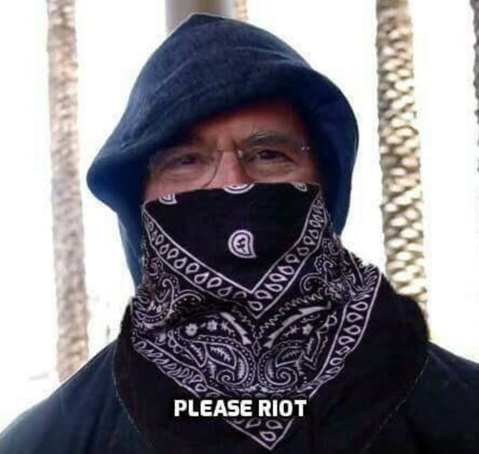
If we look at political memes from the last few years, we see some that have received massive fame, and others that have gone under the radar. One meme that was pretty big in 2016 was Jeb Bush’s “Please clap” line. Reading about it in the context of the rest of the younger Bush’s campaign is honestly a sad story, but in the moment, it was fun to joke about. What happened was that Jeb was holding a small rally in New Hampshire, and after finishing what he must have thought was “clap-worthy”, he received no applause, and the crowd was noticeably unenthused. Jeb then had to add in a defeated tone “Please clap”, which then received awkward laughter and small applause. It was covered widely in the news after the incident, and two weeks later, the country saw Jeb drop out of the presidential race. Shortly after the 2016 election, memes started going around portraying Jeb Bush as a communist and anti-fascist revolutionary. The “Comrade Jeb!” memes started through a group on Facebook known as “Sassy Socialist Memes”, and feature photoshopped images of Jeb Bush in revolutionary gear. The picture to the left is poking fun at Jeb Bush’s “Please clap” and combining it with the revolutionary idea of starting a riot.
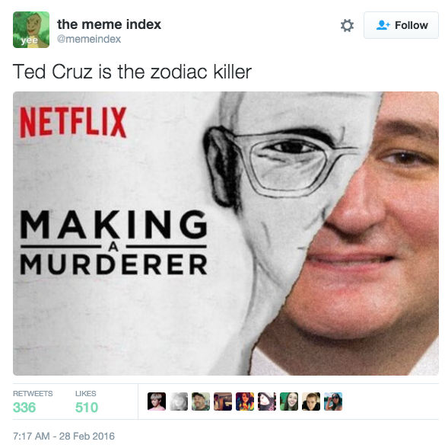
Another political meme in 2016 was the whole “Ted Cruz is the Zodiac killer” conspiracy. The California killings occurred in the 1960s and 1970s, and Cruz was born in 1970, so logically it is impossible for him to be the Zodiac killer. Despite this, the idea of it is so ridiculous, and the general consensus of the American people was that Ted Cruz was creepy, so for some reason this meme gained momentum and became a popular search term. In February of 2016, if one simply typed “is ted”, the second highest suggestion in Google’s autocomplete would be “is ted cruz the zodiac killer”. In the same month, a poll in Florida was taken before the primaries if they thought Ted Cruz was the Zodiac killer. 10% of people said they believed he was, and 28% of people were not sure. It only takes a minute to find out Ted Cruz’s birth year, and logistically it is physically not possible for him to be the Zodiac killer, but that doesn’t stop people from making jokes and memes. The anomalous juxtaposition here comes from the fact that seemingly, Ted Cruz has nothing to do with the Zodiac killer. It was from a time before Cruz was even born, and there’s no way that he could be the killer. The meme to the left equates Cruz to the killer, while also referencing the Netflix special “Making a Murderer”, a show about Steven Avery and the murder of Teresa Hallbach.
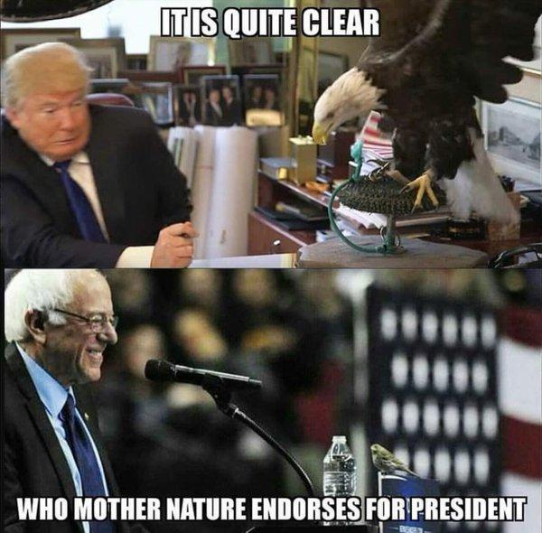
This third meme comes from Bernie Sanders’ campaign during the 2016 election. There was one rally Bernie was holding in Portland, Oregon in March 2016, where in the middle of his speech, a small bird flew onto his podium. Nothing really happened with it, there was just a bird on the podium, pecking about on the wooden surface. Bernie tried to continue his speech but the bird, aptly named “Birdie Sanders” by his supporters, was too distracting, and people started cheering for this small bird. This moment gave the impression that Bernie was very friendly and delicate with small creatures, something seen as a positive in the eyes of his supporters. The meme below compares this Birdie Sanders chance encounter with a Time photoshoot that Trump did in 2015, where he was posing with an eagle named Uncle Sam, and then was promptly attacked by the bird. This comparison is valid, because at the time, they were both presidential candidates, and they both had a chance encounter with a bird. One of the experiences went positively, and the other went negatively. The meme suggests that because of this, then Mother Nature must endorse Bernie Sanders, and denounce Donald Trump. While we may wish that this was true, the events of the 2016 election unfortunately did not play out this way.
These applications revealed that certain parts of the 2016 election have become more memorable as a result of memes and popular widespread of information. If something is talked about in the news, it may be discussed afterward, but soon a point will come where that information won’t really matter. The memorable parts of the 2016 election came from all the memes: Ted Cruz being the Zodiac Killer, Jeb Bush telling the audience to clap, Birdie Sanders, Marco Rubio sitting in an enormous chair because Trump called him little, Hillary giving her famous “Just chillin’ in Cedar Rapids!” quote, Ben Carson not walking out when his name was called, and many others. There isn’t enough room in this paper to discuss all of these memes that came from the 2016 election, but they sparked a lot of subsequent conversations about the memes, and became memorable as a result. It was effective in the way that these memes got people talking, and they are now able to be brought up in future conversations, like “hey remember when Trump had that picture of him eating KFC with a knife and fork on Air Force One?”. And then if Trump ever tries to come out and say that he eats chicken with his yuge hands, people can pull up receipts and say “where’s your knife and fork at?”. Ethical is up for debate. It may not bring the Bush family the highest amount of joy to know that Jeb Bush was basically the laughing stock of the 2016 primaries, and to know that after the election, he was ironically supported for how poorly he ran his campaign. It is, however, good for democracy because it helps increase communication in the marketplace of ideas.
To conclude, political memes are good for increasing discourse and encouraging conversation. It gets people thinking about what is happening in the world, whether it directly relates to what a certain politician said or did, or if it’s any kind of meme about a current event. There were a lot of memes in the 2016 primaries and the general election, which may have contributed to the fact that we have a living meme as our president. Maybe we voted him in because we didn’t want to lose the memes. Probably not, but who knows?
References
Apatow, Judd. (Producer,) & McKay, Adam (Director). (2008). Step Brothers [Motion Picture]. United States: Sony Pictures Releasing.
Bush, J. (2016, February). Jeb Bush New Hampshire Rally. Jeb Bush New Hampshire Rally. Laconia.
Feige, K. (Producer), & Coogler, R. (Director). (2018). Black Panther [Motion Picture]. United States: Marvel Studios.
Hall, T. E., & Sinclair, B. (2019). A connected America: politics in the era of social media. New York: Oxford University Press.

Hall, T. E., & Sinclair, B. (2019). A connected America: politics in the era of social media. New York: Oxford University Press.
Apatow, J. (Producer,) & McKay, A. (Director). (2008). Step Brothers [Motion Picture]. United States: Sony Pictures Releasing.
Feige, K. (Producer), & Coogler, R. (Director). (2018). Black Panther [Motion Picture]. United States: Marvel Studios.
Bush, J. (2016, February). Jeb Bush New Hampshire Rally. Jeb Bush New Hampshire Rally. Laconia.

