Garrett Badalich
Image and Sound Essay
Introduction
The scene that I was looking to analyze for this essay is the scene right before the battle between Anakin and Obi-Wan at the end of Star Wars Episode III: Revenge of the Sith. The timestamps specifically in this scene are from 1:46:07 to 1:47:58, starting with the appearance of Obi-Wan Kenobi, and ending with the lightsabers clashing. This is the ultimate culmination of the prequel trilogy: we have seen Anakin Skywalker’s origins on Tatooine, his training under Obi-Wan Kenobi, his falling in love with Queen Padme Amidala, and after a series of dreams and visions that suggest she will die in childbirth, his search for power that leads him to fall to the dark side and take on the new name of Darth Vader. It’s a very emotional scene, because up until this point, you never got to see why the villian did what he did. For Anakin, the whole prequel trilogy is his story, the start of the aptly-named Skywalker Saga. Fight scenes in movies are generally the catharsis of anger, releasing emotion after longtime buildup, and can be held in high regard because of their intensity level. In Revenge of the Sith, one could make the argument that the scene right before the fight holds just as much intense emotion.
Light/Dark Dynamic
After Padme’s “Because of what you’ve done! What you plan to do” line, the light hits Anakin’s face on the right side, casting a shadow and hiding almost half of his face. This is probably to symbolize Anakin’s full descent into the dark side: he has turned, quite literally, away from the light. Obi-Wan stands, hands on his hips, at the entrance of the ship. There are white lights above him, symbolizing Obi-Wan’s allegiance to the Republic, and the Jedi council.
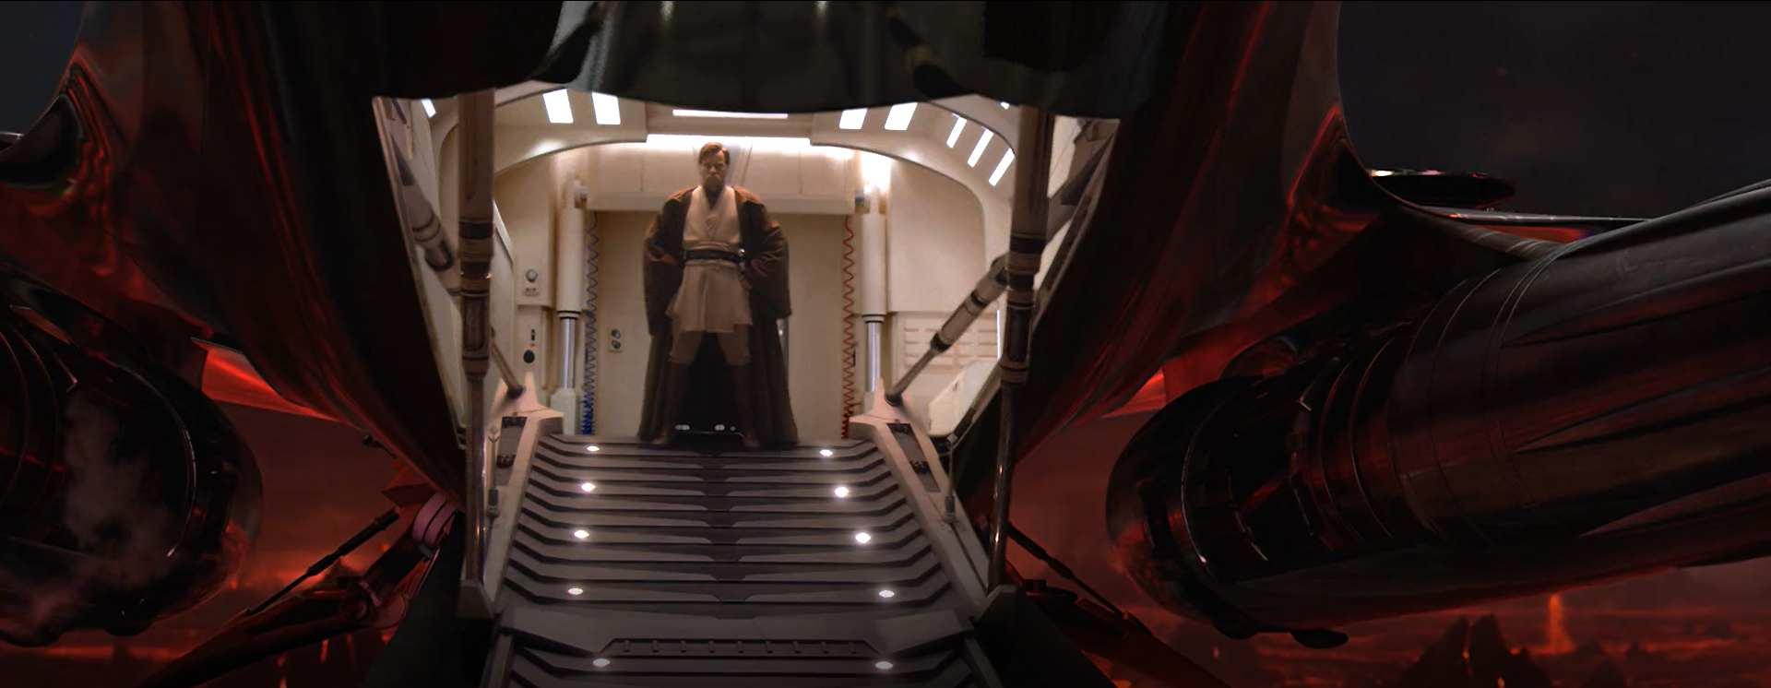Anakin’s face, when the camera goes back to him, is still partly hidden by shadows, but now the shadow is over his whole face, instead of half. Seeing Obi-Wan has fully ignited Anakin’s hatred for him, and not to sound like a broken record, but it also symbolizes the fall to the dark side. Obi-Wan gives his “You have done that yourself!” line, and his face is fully visible. While some shadow can be seen on the side of his face, his features can be seen, maybe showing that Obi-Wan has temptations and evils of his own, but he is able to fight through them and not be swayed. Even the outfits that Obi-Wan and Anakin can be seen as foreshadowing; since the start of Episode 2 Anakin has worn a lot of black, while Obi-Wan prefers white, tan, and brown colors. The light and dark dynamic of Obi-Wan and Anakin act as a literal yin and yang; the two complete each other, even if one is now turned evil. As the two Jedi exchange words, lava erupts in the background, leaving a short burst of light. Anakin says the line “If you are not with me, then you are my enemy”, and Obi-Wan responds “Only a Sith deals in absolutes”. He reaches for his lightsaber and says “I will do what I must”. As he does this, black clouds in the sky can be seen, covering a glimmer of sun. This sun could be a potential symbol for Obi-Wan’s light shining down on him, and how even when his apprentice has betrayed him, there is still light and still good. Obi-Wan turns on his lightsaber, and then soon after, Anakin turns on his own, backflips to Obi-Wan, and the fight begins.
Camera work
When Padme gives her “What you plan to do” line, the camera here shows Anakin in a medium close-up, just below his shoulders, as he stands just right of center. This is most likely to show attention to his face, as well as have the ominous Mustafar night sky in the background, and metal walls. Nothing about this environment is pleasant; it is very harsh and dangerous, a possible foreshadow of the battle that is about to ensue. When the scene switches to Obi-Wan, the camera shot is far enough out to see his stern face, the ominous Mustafar volcanoes with molten lava, and the shiny silver ship. This ship is sleek and new-looking, perhaps a reflection of the advanced technology that the Jedi possess, and how well-off Anakin would be if he resisted his lust for power. The scene continues, switching from medium close-ups of Anakin, and long shots of Obi-Wan. Anakin sees Obi-Wan, and yells “Liar!” and “You are with him! You brought him here to kill me!” as he force chokes Padme. It switches to an over-the-shoulder shot of Anakin as he does this. Obi-Wan sternly tells him to let her go. He does, and now both characters have medium close-ups as the dialogue continues. Medium close-ups are close enough to show emotion (or lack thereof) on people’s faces; when Anakin chokes Padme, Obi-Wan’s mouth is slightly agape, out of surprise of seeing his former apprentice do this. It is reminiscent of Obi-Wan seeing the archive recordings of Anakin killing younglings on Coruscant from earlier in the film. He is disappointed in him, and cannot believe the evil that he is doing. Anakin’s scenes are slightly right of center, while Obi-Wan’s have turned left of center. This is perhaps to show that both Anakin and Obi-Wan complement each other, further evidence for the yin and yang example. Anakin takes off his robe and yells “You will not take her from me!”, and while this happens, the camera changes to a two shot angle of the Jedi. It is kind of similar to an over-the-shoulder shot from Anakin, but he is too far to the right, and his whole body can be seen as well as Obi-Wan’s. This is a duel that is about to happen, so it is most appropriate to have a sort of standoff, while Anakin paces in the foreground. 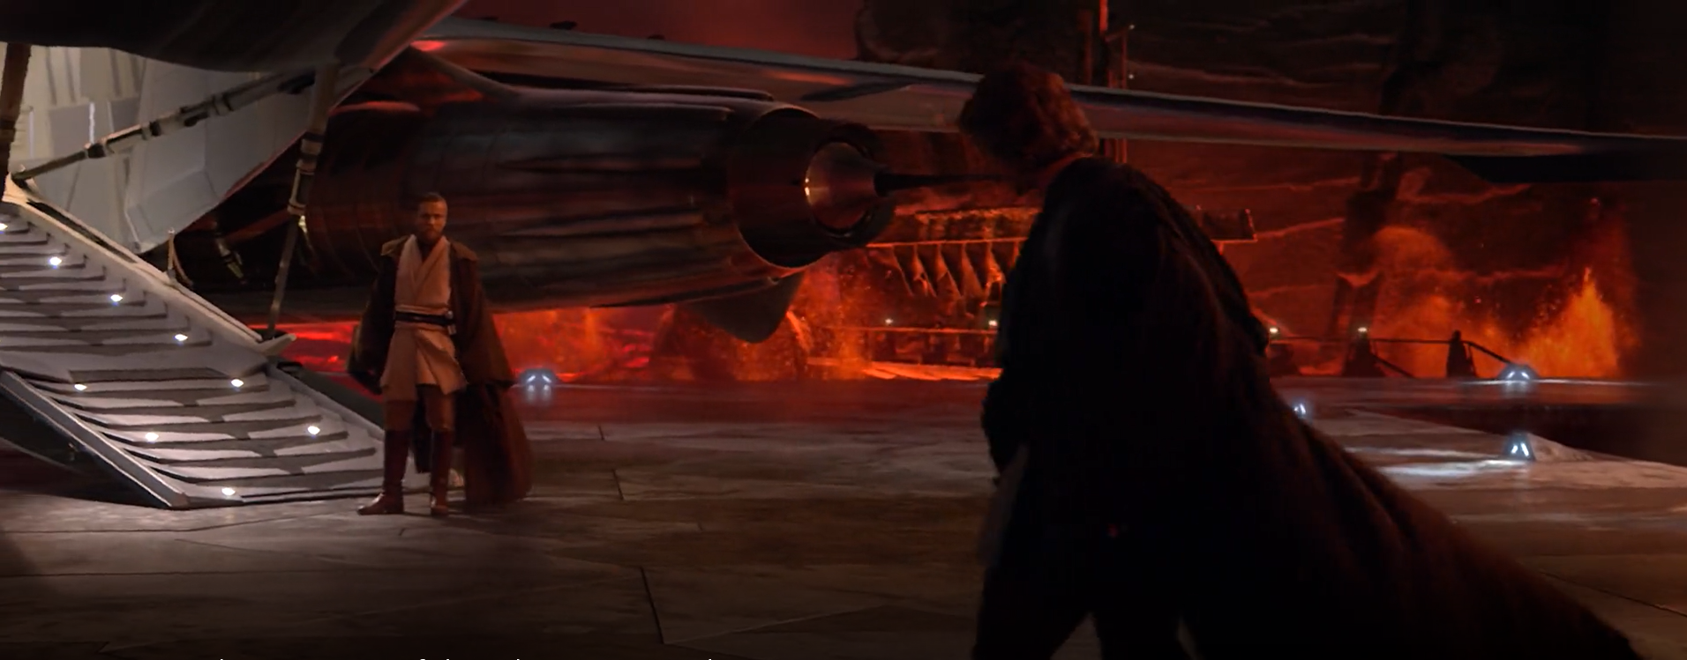It almost looks like a Spaghetti Western at this point. Anakin has another medium close-up after this, but Obi-Wan stays at a long-shot. Being the Jedi Master, Obi-Wan has more power, and the whole body-shot reflects this. He is even given the low angle, as it is pointing up at him, usually indicative as having a position of power. Obi-Wan starts his line “You have allowed this dark lord to twist your mind, until now…” and the camera cuts to an extreme long-shot. The two Jedi are seen under the ship, and a few spotlights are beaming down near Anakin. This could perhaps be an attempt to bring Anakin back to the side of the Jedi, or as a way of showing more shadows at his feet, casting more darkness than any other Jedi would be able to. Even Padme can be seen beside her husband, still unconscious from the choking incident. 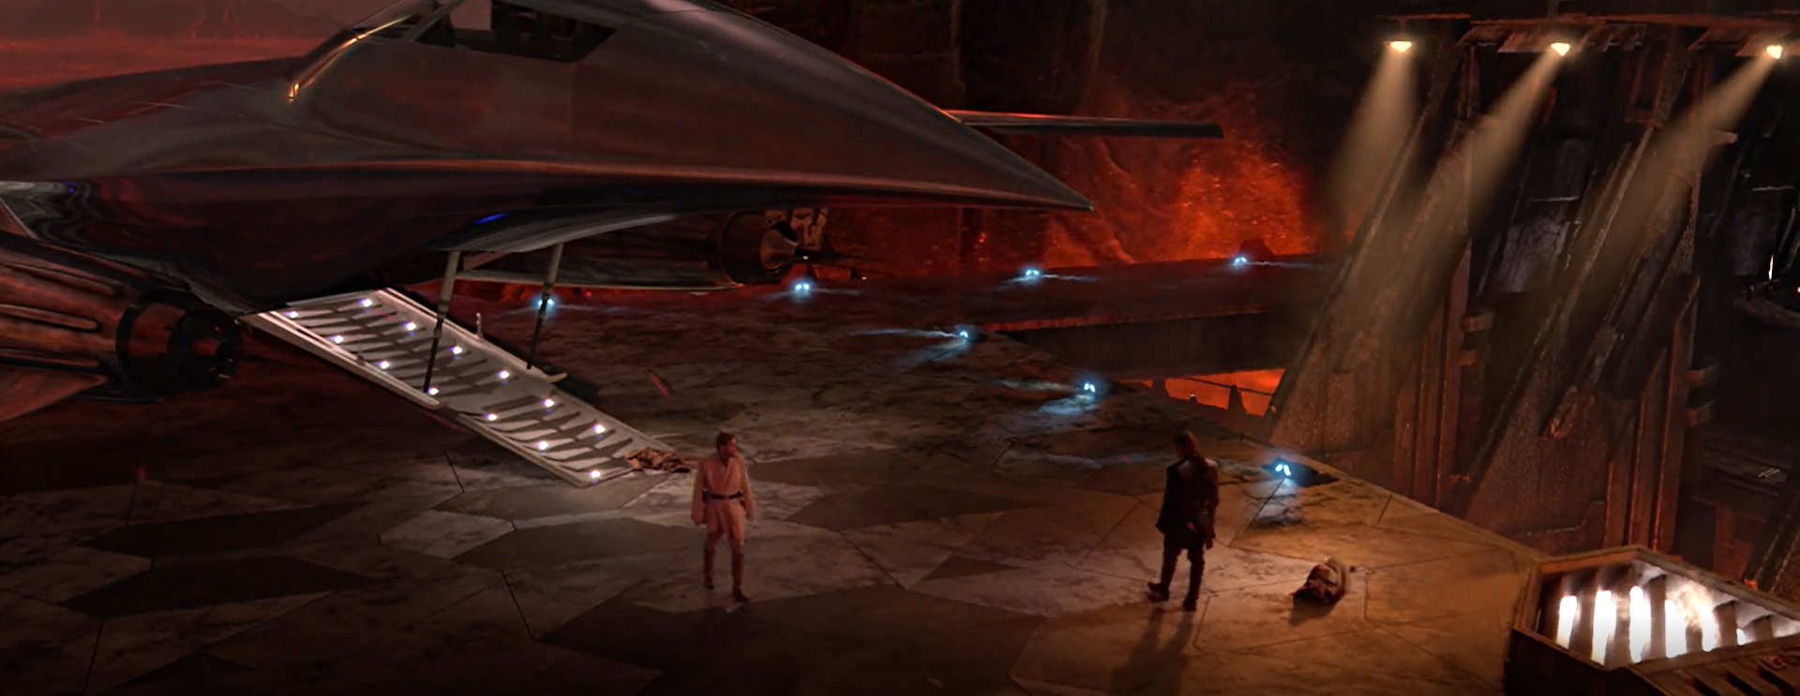Anakin tells his former master not to lecture him, and the camera cuts back to the two shot, except now both characters have paced in a semicircle, so now Obi-Wan is in the foreground. The camera changes to once again give Anakin the foreground as he begins his line of “I have brought peace, freedom, justice, and security to my new empire”, and Obi-Wan bends down to check on Padme, since she is still on the ground, unconscious. As Anakin finishes this line, it is once again in a medium close-up, with half of Anakin’s face in darkness. Obi-Wan peers over Anakin’s shoulder in the background to ask clarification, “Your new empire?” The two exchange a couple more lines, and the camera remains in the same place. Then it changes to show Anakin’s back (a point-of-view shot for Obi-Wan), as he gives the line “If you are not with me, then you are my enemy”. He turns slightly, but then returns. The camera switches to Obi-Wan, as he says “Only a Sith deals in absolutes. I will do what I must” with the medium-long shot from his knees up to above his head. Anakin gives his “You will try” line with his back to the camera once again. The sound of Obi-Wan’s lightsaber is heard as the camera switches to a two shot, with Obi-Wan once again in the background. 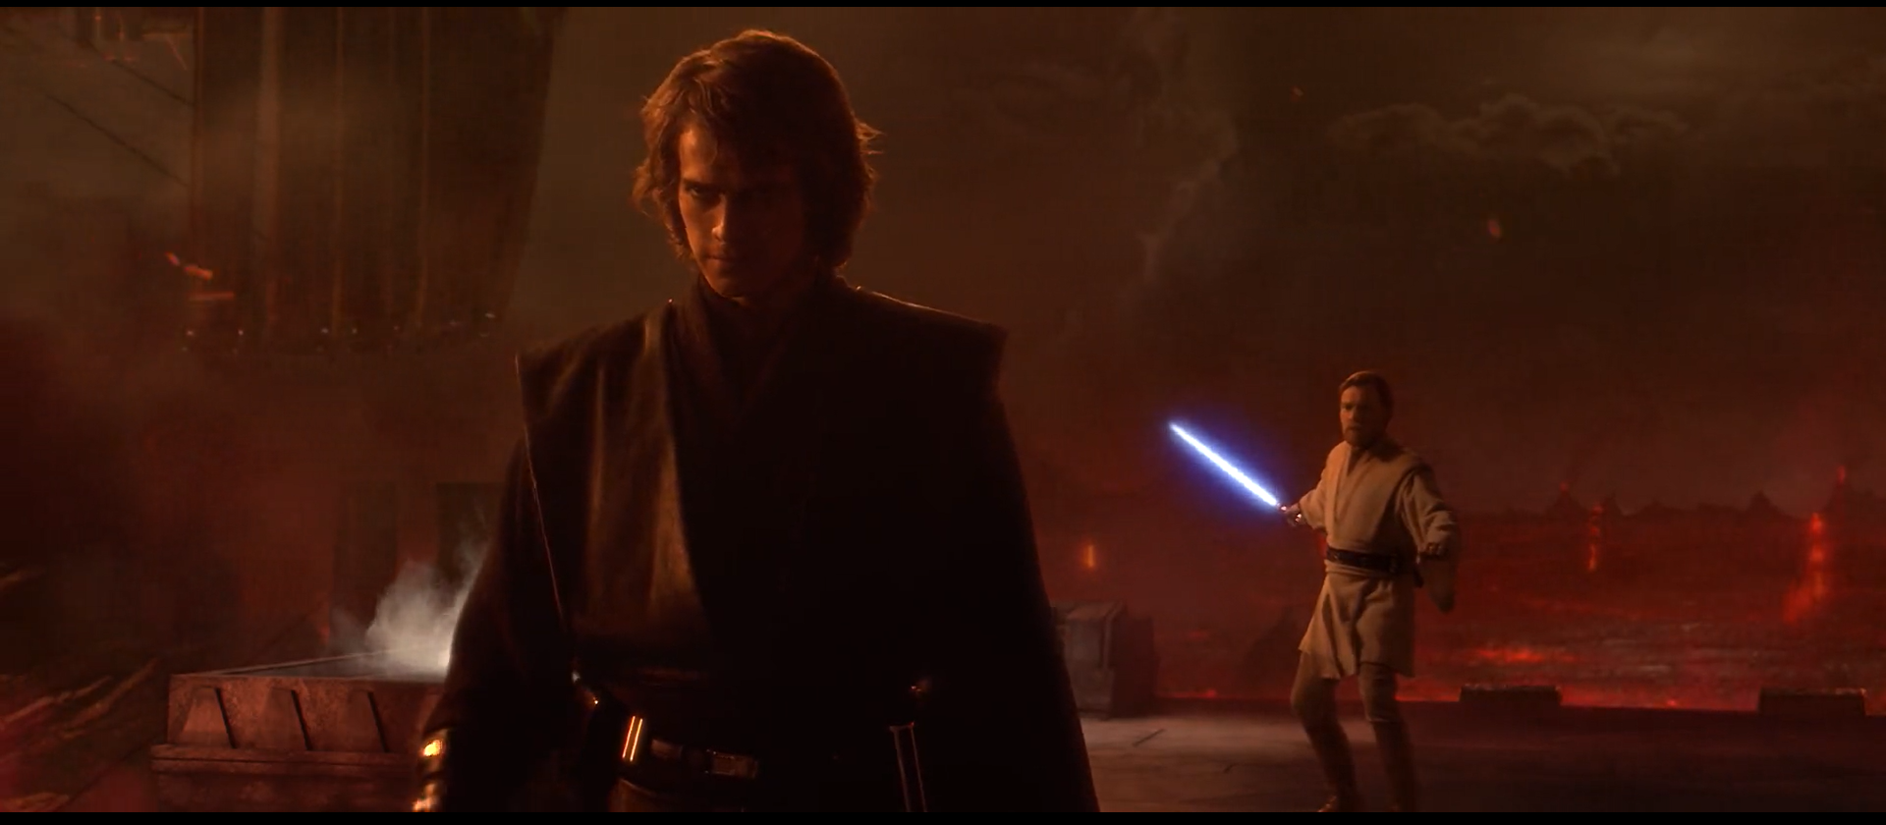Anakin draws his own lightsaber and the battle begins with Anakin doing a backflip and force leap, and then finally lightsabers clashing.
Conclusion
The focus in this whole scene stays consistent; neither character is ever out of focus, if they are on camera. Both characters provide significance to the movies as a whole, and it must have been George Lucas’ belief that neither character should ever be ignored, blocked, or out of focus. The light vs dark sides are painted very heavily in the Star Wars universe, especially through the use of Obi-Wan and Anakin in this scene. Obi-Wan exudes the light side, democracy, good, the Republic, while Anakin is dark, the Sith, Darth Vader, that sort of thing. In terms of camera work, Anakin has a lot of medium close-ups, showing his shoulders up. Focus is on his face, his anger, emotion. Obi-Wan has more long shots and the focus is on his entire body. He is seen as the Jedi to bring someone to the light, and in some figures he can be seen as a Christ figure holding the high ground above others.

