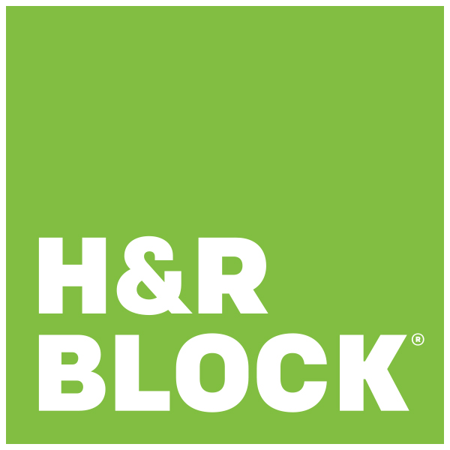
For Immediate Release:

Contact:
Rachel Schmidt
H&R Block- Green Bay WI
920-555-5555
rachel.schmidt@hrblock.com

“Shred Your Documents for FREE and Learn about Safeguarding your Tax Information through H&R Block”

GREEN BAY, WI March 24, 2018- H&R Block is hosting a paper shredding event for community members to shred documents for free.

Community members are invited to bring one box of documents to shred and recycle to promote safeguarding taxpayer information by disposing of it properly. This is the recommended method rather than simply discarding it and being at risk for thieves find it in the trash.

The 10th Annual event will take place March 24, 2018 at the Green Bay location on 601 S. Military Avenue from 9 a.m. to noon.

Shredding isn’t the only way you can protect personal documents from getting into the wrong hands. Associate members of H&R Block will be available to talk about how to safeguard and protect your important documents and give tips on how to avoid things such as cyber-attacks which have become increasingly prevalent. Additionally, they will teach you what documents you should keep indefinitely and how long to keep certain documents before shredding.

H&R Block is a global consumer tax services provider operating approximately 12,000 company-owned and franchise offices worldwide. H&R Block also sells tax software products for DIY consumers.

In 2017 alone, H&R Block prepared more than 23 million tax returns worldwide and continues to assist people around the globe to better understand their tax information.

For More information visit www.hrblock.com or call (920) 499-8781

###

