How Social Media Use Impacts the Self-Esteem of the User
Rachel Schmidt
St. Norbert College
COME 468

Abstract

This research proposal looks at the use of social media and how it impacts the self-esteem of young adult users. Through analyzing these users, their use of social media will form a relationship with how their self-esteem is either positive or negative. From a longitudinal study of high school students from the United States, the students will periodically be asked to take the survey during different stages throughout the same school year. It is expected that when these students are more active on social media (posting and liking content) that they will have an increase in self-esteem, and if they are passive social media users, they will have a decrease in self-esteem. From this study, the results will be better able to help aid in research in the field of social media usage and its impact on the self-esteem and other similar behaviors of users that are young adults.

In today’s day and age, social media is increasingly used and present among a variety of ages. Since 2016, usage of social media sites among those ages 18-29 in the United States has been on the steady increase and the highest of age groups surveyed (“Demographics of Social Media Users…”). Not only are people using more social media, the amount of times they visit that social media has also increased. According to a 2018 PEW Research Center Survey, 74% of those surveyed visited Facebook daily, with 51% of them returning several times a day to the site (Perrin & Anderson, 2019). These same trends can be seen with other social media applications or sites such as Instagram, Snapchat, YouTube, and Twitter. This information is especially interesting and important to consider not only in the context of those who are adults, but also to look at how social media use has impacted younger generations, specifically teenagers and young adults. Research has found similar connections to the use of social media and its effect on the self-esteem of the users and it is important to see how this impacts their developing minds.
This research study looks at the ways that social media use, whether active or passive, impacts high school age users. The questions raised will look to see if being more active on social media will have more of a positive impact on self-esteem compared to being passive on social media that could lead to more negative, decreased self-esteem.
Literature Review
The articles featured in this literature review relate to the use of social media and its relationship to the self-esteem of its users. It discusses the relationship of self-esteem to such factors as age, time spent on social media applications, and how self-esteem fluctuates depending on social media applications and other social factors.
The Impact on Self-Esteem
From such studies in this area of research, there has been conclusions drawn related to the overall impact of social media on the self-esteem of the user. A cross-sectional survey by Beullens and Eggermont (2019) looked at the social media habits of girls ages 9-14. The authors asked the users questions about their online popularity and the need for popularity helped to draw conclusions related to self-esteem. From their study, the authors found there to be a relationship between the self-presentation of the users and their self-esteem.
Another area that is important to consider related to the impact of self-esteem is from Mackson, Brouchu, and Schneider (2019). These authors looked at how the social media app Instagram related to a variety of factors related to well-being such as self-esteem, body image, and social comparison. From this research the authors gathered that those who had Instagram accounts ended up having a lower self-esteem than those that didn’t have it, drawing the conclusion that having social media results to a lower self-esteem compared to not having social media accounts at all.
Gonzales and Hancock (2011) completed a similar study with social media. Focusing on Facebook as the social media platform used, the authors conducted an experiment that had each of the participants examine their Facebook profiles and looked at the participants reactions. They concluded that the users who examined their pages and got positive feedback from engagement on their posts or pictures, would have an increase in their self-esteem. Also, the authors concluded that when the participants examined their profile as a whole, it could actually lead to an increase in their self-esteem overall.
Social Media Addiction
Another part of the research that is important to consider in relation to self-esteem is social media addiction. Mehdizadeh (2010) looked at the ways that Facebook usage related to self-esteem and narcissism in the participants of the questionnaire. From Mehdizadeh’s research, she found that when the survey participants had spent more time logged-in using Facebook that they had a lower self-esteem. By exploring the amount of time that one uses social media, it was concluded that it had a negative relationship with self-esteem, causing an overall negative self-esteem.
Hawi and Samaha (2016) took this idea of social media addiction and self-esteem and applied it to how it would impact college-age students. From an online survey, the authors asked about self-esteem, social media usage and satisfaction with life to see how it would affect the participants. They were able to conclude that self-esteem was in fact related to social media addiction and when students were more addicted to social media, they had a lower self-esteem.
This next research from Blanchnio, Przepiorka and Pantic (2016) was almost identical to the one from Hawi and Samaha since it focused on the same topics of self-esteem, social media addiction and satisfaction with life, but it contrasted by using a cross-sectional approach. The results found by these three authors were the same as above which resulted in a lower self-esteem related to high social media addiction.
Self-Esteem and Social Media Usage
Other research has found that the way social media is being used by the user impacts the user’s self-esteem in different ways. The way that one consumes social media will result in a different relationship with self-esteem. This theory originates from a study by Verduyn (et al.) in 2017. The authors map out active versus passive consumption. From Figure 1 from the authors research, it shows that there are two different paths one can take when consuming social media: active or passive. By using this model, it maps out a clear path of how to address the way that social media impacts one’s self-esteem. It states that active use of social media will result in feeling connected, leading to a positive subjective well-being. The passive path states that passively using social media will lead to social comparison and envy and result in a negative impact on subjective well-being (Verduyn et al.).
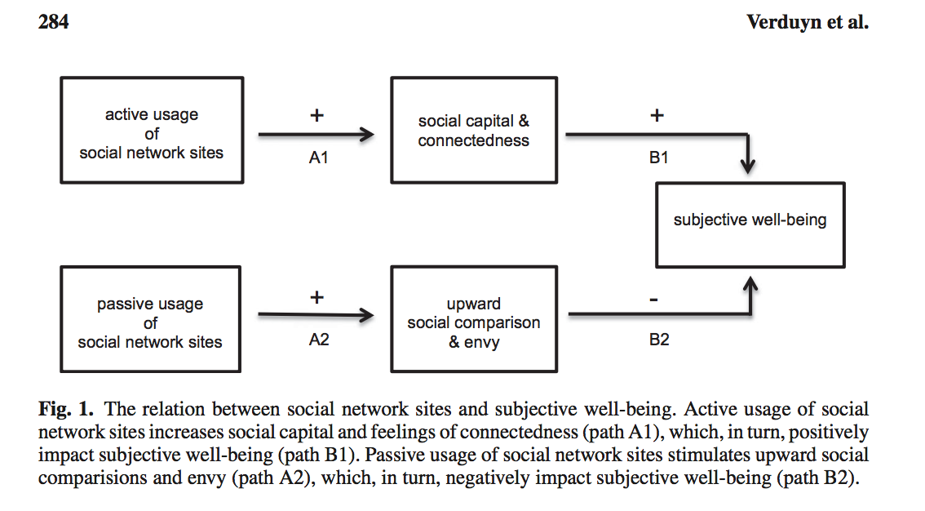
Grant and Shaw (2002) discuss how social media impacts psychological health. From this longitudinal study, the authors found that when looking at a variety of different variables such as depression, loneliness, and perceived social support compared to self-esteem, self-esteem was the last variable of the ones asked to participants that was affected by internet usage. Additionally, the authors noted that over time when the participants used the internet, self-esteem would increase.
Valkenburg and Schouten (2006) looked into a similar area of study related to usage on social media. The authors surveyed adolescents ages 10 to 19 about their social media usage. From this survey, the authors were able to find that the self-esteem that the user received was dependent on the interaction and responses that their social media profiles were receiving from others. This would mean that if their profile was filled with positive feedback, they in turn would have a positive self-esteem, and vice-versa if the profile feedback had been negative.
Hypotheses
Using the model of active versus passive consumption (from Verduyn et al.) as a basis for my research, my hypotheses will explore the relationship between both active and passive social media use and how that effects the self-esteem of the participants. Two will relate to active use and two will relate to passive use.
The first hypothesis relates to active social media use. I expect to find:
H1: The use of actively liking on social media will lead to an increase in the user’s self-esteem.
The second hypothesis that will be tested is also related to active usage of social media. I expect to find:
H2: The use of actively posting pictures, retweeting, or sharing content on social media will lead to an increase in the user’s self-esteem.
The third hypothesis relates to the other side of the model which is about passive usage of social media. I expect to find:
H3: The act of passively scrolling on social media timelines / newsfeeds will lead to a decrease in the self-esteem of the user.
The final hypothesis that will be tested is also related to passive social media usage. I expect to find:
H4: The act of passively following accounts on social media will result in a decrease in the user’s self-esteem.

Methodology
In order to assess and test these four hypotheses, a longitudinal study will be used to test the relationship that self-esteem has related to social media usage. This longitudinal study will last over the span of one full school year.
Sample
The sample size for this research will be from a midwestern high school where the students will randomly throughout the year take the survey during one of their class periods. The school size is around 730 students that are going to take the survey during a random class period six times throughout the same school year to see the changes that occur during a full year of high school.
Measures
The variables in this study that are being measured are related to self-esteem and social media behaviors (liking, commenting scrolling). There are three scales that will be included in the survey.
Social Media.
The scale used to assess social media actions will be a modified version of the Social Networking Activity Intensity Scale (SNAIS) from Li (et al) in 2016. This scale is used to assess and determine the participants use of social media and specific types of interactions/action they are or are not taking via social media/networking platforms. This scale asks the frequency that the participant preforms a social media/networking related activity. There are six categories that are options for the respondents from never (0) to always (5). There are originally 14 questions in the SNAIS, however the last four will be removed. Three additional items will be added to relate to engagement of the users on social media, resulting in 13 overall questions for this scale. The two added will be:
- Scrolled on social media newsfeeds without engaging with content.
- Liked, retweeted, or shared content on one or more social media platforms.
- Followed new accounts on social media platforms and engaging with the new accounts (liking, retweeting, sharing).
Self-Esteem.
The second scale that will be used is related to self-esteem. The Satisfaction with Life Scale (SWLS), as found in Hawi and Samaha’s study will help bridge the connections of social media use and the self-esteem of the user. This scale will ask the participants questions related to their cognitive self-judgements and contains five items. The scale is a seven-point Likert form with options from strongly disagree (7) to strongly agree (1).
The final scale used will be the Rosenberg Self-Esteem Scale (SES). This scale, found also featured in Hawi and Samaha’s research, asks about worthiness related content and self-esteem of the participants. This scale will feature 10 items for the participants to respond to. This is also a Likert scale and has five points for each of the questions from strongly disagree (1) to strongly agree (5).
Procedure
This longitudinal study is set to take place over the span of one full year of school at a midwestern high school. The students from freshman to seniors will all complete the survey that contains the different scales related to self-esteem. The students will randomly take the survey six times a year during one of their class periods. The time at which they will take it will vary and the students will not be aware ahead of time which day and what time they will take the survey each time.
The students will be asked to take the survey via the schools’ laptops that will be handed out to them during the specific occasion. These will already be logged-in to the Qualtrics survey, all the students will need to do is plug in their information. To make sure that the students over time are consistent with their individual information, they will be given a specific log-in ID in order to ensure that their information will be recorded and implemented to their specific data so as to not be confused with another student’s information. The researcher coding the results will not see the students name next to the ID, so each of the students’ identities will remain anonymous.
Results
The first step for my data analysis plan would be to clean up and organize the data. Not all of the students at the high school could have answered and fully completed the survey, so the responses that were not fully completed and students who may have missed a survey slot would be removed from evaluation. Additionally, the scales used in the survey that were in reverse code order would have to be reversed again. Then, I would create an average score of the data for each participant for each of the three scales used to compare them to each other on a more equal plane.
The next step would be to describe my data. I would want to know the gender breakdown for the survey, the age of the participant, their high school grade and their race/ethnicity. After this information, I would want to see what the average age of those completing the survey was, the most frequent gender that appeared, and the most frequent race/ethnicity.
To analyze whether or not my hypotheses were correct, I would use a series of Pearson Correlation Analyses for each hypothesis. For the first hypothesis (H1), the results from the survey would be compared with the social media activity of the participants at each time of the survey taken. If there was a relationship found between active social media use and an increase in self-esteem, this hypothesis would be supported. For the second hypothesis (H2), a similar approach would be taken to determine the active use of social media of participants and self-esteem. The questions related to the user posting content or engaging with content on social media would be examined in comparison to the SES and SWLS. If it was found that there was a correlation leading to an increase of self-esteem, the hypothesis would be proven correct. For the third hypothesis (H3), the questions on the SNAIS that resulted in a response of 0 or never, and results on the SES and SWLS that are low, would make this hypothesis proven correct. For the final hypothesis (H4), the final question on the SNAIS will be used in comparison to the SES and SWLS, and if true, the hypothesis will be supported.
Discussion
Limitations
Potential limits of this research study could be due to the fact that there could be more than one factor impacting a social media users’ self-esteem when they use social media. Their relational history or experience with a person whose posts are on their newsfeed/timeline could impact them differently as to whether or not they are active or passive in their social media use. Additionally, the students that were randomly surveyed may have missed a day when the survey was given due to illness or other absence, so their information may not fully reflect what happened in actuality when all their data is looked at when the study is completed. Also, because the school is in the Midwest and only at one high school, there may not be an equal representation of race and gender, so the generalizability of the study will be limited. Since this is also a longitudinal study and the survey will be asked 6 times throughout the year, the students may pick up on what is being asked and try to answer in the best way possible and not accurately to what they are actually feeling overtime.
Implications
Although there are limitations to this longitudinal study, this research will be beneficial to the growing field interested in the effects of social media on users. Social media results in different effects on its users and what they get out of each visit to may result in a different effect on individuals’ self-esteem. Being able to see if this stems from the user’s active or passive actions on social media platforms will be useful to help better understand how to modify and monitor social media platforms. Also, since a lot of the research that has been done has been about college or high school aged young adults, it is important to complete another research study related to the topic to see if it is consistent with the other research out there and has replicability. Overall, this study in social media and self-esteem will help better a growing area of study and spark more studies that are similar to look into this relationship and how it effects high school age young adults in the United States, and help users become more aware of their social media habits.

References

Błachnio, A., Przepiorka, A., & Pantic, I. (2016). Association between Facebook addiction, self-esteem and life satisfaction: A cross-sectional study. Computers in Human Behavior, 55, 701–705.

“Demographics of Social Media Users and Adoption in the United States.” (2019, June 12). Retrieved from https://www.pewresearch.org/internet/fact-sheet/social-media/.

Gant, Larry M. & Shaw, Lindsay H. (2002). In Defense of the Internet: The Relationship
between Internet Communication and Depression, Loneliness, Self-Esteem, and Perceived Social Support. Cyberpsychology, Behavior, and Social Networking 5(2), 157-171.

Gonzales, A. L., & Hancock, J. T. (2011). Mirror, mirror on my Facebook wall: Effects of exposure to Facebook on self-esteem. Cyberpsychology, Behavior, and Social Networking, 14(1–2), 79–83.

Hawi, Nazir S. & Samaha, Maya. (2016). The Relations Among Social Media Addiction, Self-Esteem, and Life Satisfaction in University Students. Social Science Computer Review 2017 35(5), 576-586.

Li, Jibin, Lau, J. T. F., Mo, P. K. H., Xuefen Su, Wu, A. M. S., Jie Tang, & Zuguo Qin. (2016). Validation of the Social Networking Activity Intensity Scale among Junior Middle School Students in China. PLoS ONE, 11(10), 1–14. https://doi-org.snc.idm.oclc.org/10.1371/journal.pone.0165695

Mackson, S. B., Brochu, P. M., & Schneider, B. A. (2019). Instagram: Friend or foe? The application’s association with psychological well-being. New Media & Society, 21(10), 2160–2182. https://doi-org.snc.idm.oclc.org/10.1177/1461444819840021

Meeus, A., Beullens, K., & Eggermont, S. (2019). Like me (please?): Connecting online self-presentation to pre- and early adolescents’ self-esteem. New Media & Society, 21(11/12), 2386–2403. https://doi-org.snc.idm.oclc.org/10.1177/1461444819847447

Mehdizadeh, Soraya. (2010). Self-Presentation 2.0: Narcissism and Self-Esteem on Facebook. Cyberpsychology, Behavior, and Social Networking, 13(4), 357-364.

Perrin, A., & Anderson, M. (2019, April 10). Share of U.S. adults using social media, including Facebook, is mostly unchanged since 2018. Retrieved from https://www.pewresearch.org/fact-tank/2019/04/10/share-of-u-s-adults-using-social-media-including-facebook-is-mostly-unchanged-since-2018/.

Valkenburg, P. M., Peter, J., & Schouten, A. P. (2006). Friend Networking Sites and Their Relationship to Adolescents' Well-Being and Social Self-Esteem. CyberPsychology & Behavior, 9(5), 584-590.

Verduyn, P., Ybarra, O., Résibois, M., Jonides, J., & Kross, E. (2017). Do Social Network Sites Enhance or Undermine Subjective Well-Being? A Critical Review. Social Issues & Policy Review, 11(1), 274–302. https://doi-org.snc.idm.oclc.org/10.1111/sipr.12033

